The Groundwater Model Component

Caleb A. Buahin, Bethany T. Neilson

Utah Water Research Laboratory

December 6, 2018

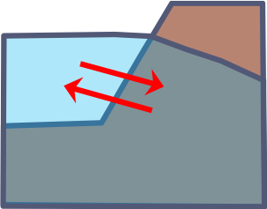

Table of Contents

1 Introduction 3

2 Mass Transport Formulations 4

1.1 Mass Flux Exchanges with Channel 6

3 Heat Transport Formulations 8

1.2 Heat Conduction and Dispersion 9

1.3 Heat Advection 10

1.4 Heat Flux Exchanges with Channel 10

4 Solute Transport Formulations 11

1.5 Solute Dispersion 12

1.6 Solute Advection 12

5 Solvers 12

6 Comparison with Analytical Solutions 13

1.7 Mass Transport 13

1.8 Heat Transport 16

1.9 Solute Transport 16

7 Hydropeaking Numerical Experiments 16

References 17

# Introduction

This document describes the groundwater model GWComponent, developed to simulate mass, heat, and solute fluxes exchanged between a river channel and its adjacent shallow groundwater zone. The GWComponent solves the vertically-averaged unconfined saturated groundwater flow equations and the heat and solute transport equations using the semi-discrete finite volume approximation. The underlying assumption we make is that the principal directions of flow are perpendicular to the channel (i.e., lateral) and along the channel (i.e., longitudinal) as depicted in Figure 1. The GWComponent was developed to be primarily used and coupled with other components within the HydroCouple component-based modeling framework (Buahin and Horsburgh, 2016; Buahin and Horsburgh, 2018). However, it can be compiled and used as a standalone executable.

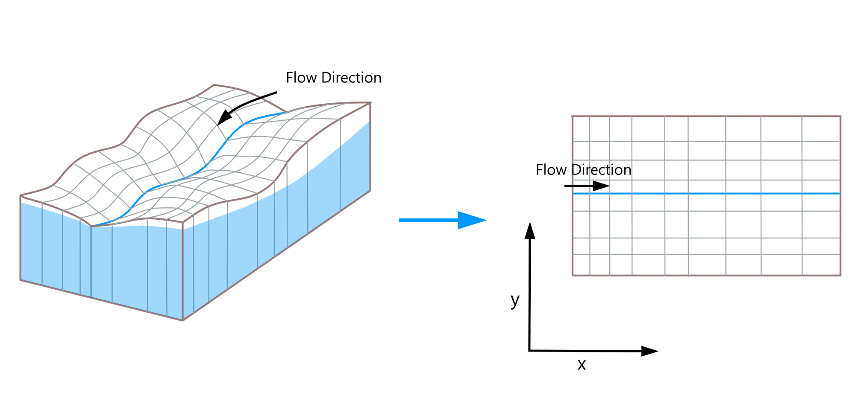

Figure 1. GWComponent spatial domain simplification schematic

# Mass Transport Formulations

The vertically-averaged unconfined saturated groundwater flow equations solved by the GWComponent is shown in equation 1:

$\frac{∂}{∂x}\left(K_{x}b\frac{∂h}{∂x}\right)+\frac{∂}{∂y}\left(K_{y}b\frac{∂h}{∂y}\right)+bQ=S_{O}\frac{∂h}{∂t}$ (1)

where $x$ and $y$ are distances in the longitudinal and lateral directions respectively $\left(m\right)$, $K_{x}$ and $K_{y}$ and hydraulic conductivity values in the longitudinal and lateral directions respectively $\left(\frac{m}{s}\right)$, $h$ is the hydraulic head $\left(m\right)$, $b$ is the saturated thickness of the aquifer $\left(m\right)$, $Q$ represent external water fluxes $\left(\frac{m^{3}}{s∙m^{3}}\right)$, $S_{O}$ is the storage coefficient (i.e., specific yield for an unconfined aquifer) $\left(\frac{m}{m}\right)$, and $t$ is time $\left(s\right)$.

Applying the finite volume approximation over the control volume ${CV}_{i,j}$ in the model domain shown in Figure 2 over a time step $∆t$ $\left(s\right)$,yields equation 2.

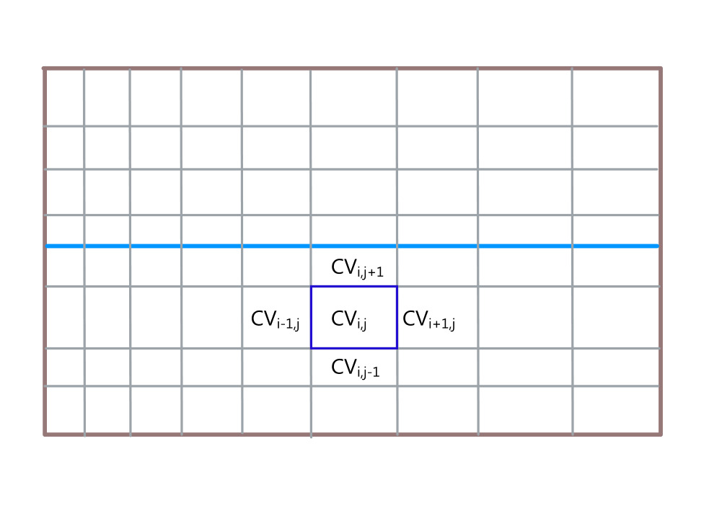

Figure 2. Control volume schematic

$\int_{∆t}{\int_{CV}{\left[\frac{∂}{∂x}\left(K_{x}b\frac{∂h}{∂x}\right)\right]}dVdt}+\int_{∆t}{\int_{CV}{\left[\frac{∂}{∂y}\left(K_{y}b\frac{∂h}{∂y}\right)\right]}dVdt}+\int_{∆t}{\int_{CV}{\left(bQ\right)dVdt}}=\int_{∆t}{\left[\int_{CV}{\left(S_{O}\frac{∂h}{∂t}\right)}dV\right]dt}$ (2)

where V is the volume of the control volume CV $\left(m^{3}\right)$. Using the explicit time marching method and applying the Gauss divergence theorem to equation 2 yields equation 3.

$\sum_{k=1}^{NBx}{\left(K_{x}b\frac{∂h}{∂x}\right)A_{NBx}}+\sum_{k=1}^{NBy}{\left(K_{y}b\frac{∂h}{∂y}\right)A_{NBy}}+bQV=S_{O}\left(\frac{h^{t+∆t}-h^{t}}{∆t}V+\frac{V^{t+∆t}-V^{t}}{∆t}h\right)$ (3)

where $\sum_{k=1}^{NBx}{} and\sum_{k=1}^{NBy}{}$ represent the summation of their respective terms in the x and y directions respectively at the boundaries of the control volume, $A_{NBx}$ and $A_{NBy}$ represent the cross sectional area of flow in the x and y directions at the boundaries of the control volume respectively $\left(m^{2}\right)$, and superscripts $t$ and t+ $∆t$ represent the current and next time step a solution is being sought $\left(s\right)$. The first two terms on the right-hand side of equation 3 are approximated numerically as follows for the control volume boundaries:

$\sum_{k=1}^{NBx}{\left(K_{x}b\frac{∂h}{∂x}\right)A_{NBx}}=K_{i+\frac{1}{2},j}b\left(\frac{h_{i+1, j}-h_{i,j}}{\frac{{∆x}_{i+1,j}}{2}+\frac{{∆x}_{i,j}}{2}}\right)b∆y-K_{i-\frac{1}{2},j}b\left(\frac{h_{i, j}-h_{i-1,j}}{\frac{{∆x}_{i,j}}{2}+\frac{{∆x}_{i-1,j}}{2}}\right)b∆y$ (4)

$\sum_{k=1}^{NBy}{\left(K_{y}b\frac{∂h}{∂y}\right)A_{NBy}}=K_{i,j+\frac{1}{2}}b\left(\frac{h_{i, j+1}-h_{i,j}}{\frac{{∆y}_{i,j+1}}{2}+\frac{{∆y}_{i,j}}{2}}\right)b∆x-K_{i,j-\frac{1}{2}}b\left(\frac{h_{i, j}-h_{i,j-1}}{\frac{{∆y}_{i,j}}{2}+\frac{{∆y}_{i,j-1}}{2}}\right)b∆x$ (5)

where the subscripts $i$ and $j$ represent the current control volume, the subscripts $i-1$, $i+1$, $j-1$, and $j+1$ represent neighboring control volumes on the left, right, south, and north of the current control volume respectively, and the subscripts $i-\frac{1}{2}$, $i+\frac{1}{2}$, $j-\frac{1}{2}$, $j+\frac{1}{2}$ represent boundaries of the control volume on the left, right, south, and north sides respectively, and $∆x$ and $∆y$ represent the sizes of the control volumes in the x and y directions respectively $(m)$.

The effective hydraulic conductivity values at the boundary between any two cells that are used in equations 4 and 5 are calculated based on formulations by Leonards (1962) and are shown as follows:

$K_{i+\frac{1}{2},j}=\left(\frac{\frac{{∆x}_{i,j}}{2}+\frac{{∆x}_{i+1,j}}{2}}{\frac{\frac{{∆x}_{i,j}}{2}}{K_{i,j}}+\frac{\frac{{∆x}_{i+1,j}}{2}}{K_{i+1,j}}}\right)$ (6)

$K_{i-\frac{1}{2},j}=\left(\frac{\frac{{∆x}_{i,j}}{2}+\frac{{∆x}_{i-1,j}}{2}}{\frac{\frac{{∆x}_{i,j}}{2}}{K_{i,j}}+\frac{\frac{{∆x}_{i-1,j}}{2}}{K_{i-1,j}}}\right)$ (7)

$K_{i,j+1}=\left(\frac{\frac{{∆y}_{i,j}}{2}+\frac{{∆y}_{i,j+1}}{2}}{\frac{\frac{{∆y}_{i,j}}{2}}{K_{i,j}}+\frac{\frac{{∆y}_{i,j+1}}{2}}{K_{i,j+1}}}\right)$ (8)

$K_{i,j+1}=\left(\frac{\frac{{∆y}_{i,j}}{2}+\frac{{∆y}_{i,j+1}}{2}}{\frac{\frac{{∆y}_{i,j}}{2}}{K_{i,j}}+\frac{\frac{{∆y}_{i,j+1}}{2}}{K_{i,j+1}}}\right)$ (9)

## Mass Flux Exchanges with Channel

The mass exchanges between the aquifer and the channel is computed using formulations used in the River package of the U.S. Geological Survey Modular Ground-Water Model (MODFLOW), which assumes a partially penetrating river with a semi confining bed layer (Harbaugh, 2005). Flow into and out of the aquifer is computed as a function of the relative differences in hydraulic heads in the underlying groundwater cell and the channel as well as the elevation of the channel bottom. The three configurations for flux exchanges are depicted in Figure 3.

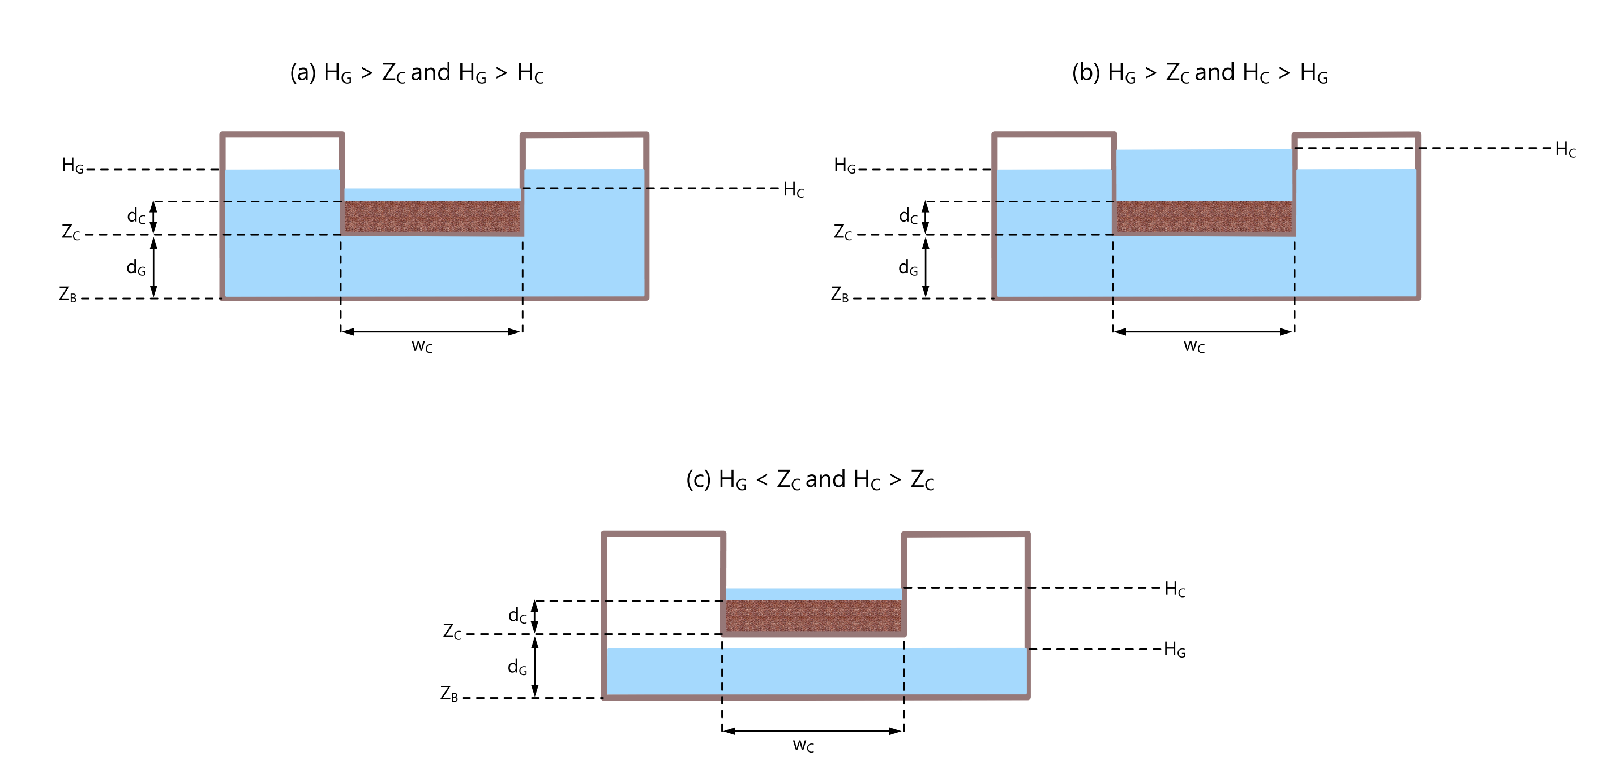

Figure 3. Groundwater-surface water exchange configurations

For configurations a and b, where the hydraulic head (HG) in the underlying cell is greater than channel bottom elevation, the flow into/out of the aquifer is computed as follows:

$Q_{C}=K_{eff}\left(\frac{H_{C}-H_{G}}{\frac{d_{C}}{2}+\frac{d_{G}}{2}}\right)w_{c}∆x$ (10)

where $K_{eff}$ is the effective hydraulic conductivity in the z direction $\left(\frac{m}{s}\right)$, $H_{C}$ is the hydraulic head in the channel $\left(m\right)$, $d_{C}$ is the thickness of the semi-confining bed layer $\left(m\right)$, $d_{G}$ is the saturated thickness of the aquifer $\left(m\right)$, and $w_{C}$ is the width of the channel $\left(m\right)$. $K_{eff}$ is calculated in a similar fashion to the boundary hydraulic conductivities as follows:

$K_{eff}=\frac{\frac{d_{C}}{2}+\frac{d_{G}}{2}}{\frac{\frac{d_{C}}{2}}{K_{C}}+\frac{\frac{d_{G}}{2}}{K_{z}}}$ (11)

where $K_{C}$ is the hydraulic conductivity of the semi-confining bed layer in the z direction $\left(\frac{m}{s}\right)$ and $K_{Z}$ is the hydraulic conductivity of the underlying groundwater cell in the z direction $\left(\frac{m}{s}\right)$.

For scenario c, the flow out of the channel into the aquifer is computed using the following equation:

$Q_{C}=K_{C}\left(\frac{H_{C}-Z_{C}}{\frac{d_{C}}{2}}\right)w_{c}∆x$ (12)

where $Z_{C}$ is the elevation of the channel bed $\left(m\right)$.

# Heat Transport Formulations

The two-dimensional advection, dispersion, and conduction groundwater heat transport equations (de Marsily, 1986; Domenico and Schwartz, 1998) that the GWComponent solves is shown in equation 13:

$nρ_{w}c_{w}\frac{∂T_{w}}{∂t}+\left(1-n\right)ρ_{s}c_{s}\frac{∂T_{s}}{∂t}=∇∙\left[ \left(λ_{m}+nρ_{w}c_{w}αv\right)∇T\right]-∇∙\left(nρ_{w}c_{w}vT\right)+q_{h}$ (13)

where n is the porosity, $ρ_{w}$ and $ρ_{s}$ are water and sediment density respectively $\left(\frac{kg}{m^{3}}\right)$, $c_{w}$ and $c_{s}$ are specific heat capacity of water and sediment respectively $\left(\frac{J}{kg°C}\right)$, $T_{w}$ and $T_{s}$ are temperatures of the water and sediment respectively $\left(°C\right)$, $T$ is the temperature of both water and sediment $\left(°C\right)$, $λ_{m}$ is effective thermal conductivity of the sediment and water $\left(\frac{W}{m°C}\right)$, $α$ is the dispersivity $\left(m\right)$, $v$ is seepage velocity $\left(\frac{m}{s}\right)$, and $q_{h}$ is the sum of external heat sources $\left(\frac{W}{m^{3}}\right)$.

A valid assumption to make for many cases is that the temperature of the sediment and water are the same and that there is no transfer of heat from one to the other (Hecht‐Méndez *et al.*, 2010; Nield and Bejan, 2013). Under this assumption, equation 13 can be expressed in the following form:

$ρ_{m}c_{m}\frac{∂T}{∂t}=\overset{Conduction and Dispersion}{\overbrace{∇∙\left[ \left(λ_{m}+nρ_{w}c_{w}αv\right)∇T\right]}}-\overset{Advection}{\overbrace{∇∙\left(nρ_{w}c_{w}vT\right)}}+q_{h}$ (14)

where $ρ_{m}c_{m}$ is the heat capacity per unit volume of the combined sediment and water medium $\left(\frac{J}{m^{3}°C}\right)$. $ρ_{m}c_{m}$ is computed as the weighted average of the sediment and pore water (Domenico and Schwartz, 1998; Hecht‐Méndez *et al.*, 2010) as shown in equation 15. $λ_{m}$ is calculated in a similar manner as shown in equation 16.

$ρ_{m}c_{m}=nρ_{w}c_{w}+\left(1-n\right)ρ_{s}c_{s}$ (15)

$λ_{m}=nλ_{w}+\left(1-n\right)λ_{s}$ (16)

where $λ_{w}$ and $λ_{s}$ thermal conductivity of the water and sediment respectively $\left(\frac{W}{m°C}\right)$.

The finite volume approximation of equation 14 is shown in equation 17. Adopting the explicit time marching approach yields equation 18.

$\int_{∆t}{\int_{CV}{ρ_{m}c_{m}\frac{∂T}{∂t}}dVdt}=\int_{∆t}{\int_{CV}{∇∙\left[ \left(λ_{m}+nρ_{w}c_{w}αv\right)∇T\right]dVdt}}-\int_{∆t}{\int_{CV}{∇∙\left(nρ_{w}c_{w}vT\right)}}dVdt+\int_{∆t}{\int_{CV}{q_{h}}dVdt}$ (17)

$ρ_{m}c_{m}\left(\frac{T^{t+∆t}-T^{t}}{∆t}V+T\frac{V^{t+∆t}-V^{t}}{∆t}\right)=\int_{CV}{∇∙\left[ \left(λ_{m}+nρ_{w}c_{w}αv\right)∇T\right]dV}-\int_{CV}{∇∙\left(nρ_{w}c_{w}vT\right)}dV+\int_{CV}{q_{h}}dV$ (18)

## Heat Conduction and Dispersion

Applying the Gauss divergence theorem, the heat conduction and dispersion terms are discretized numerically for the control volume CV as follows:

$\int_{CV}{∇∙\left[ \left(λ_{m}+nρ_{w}c_{w}αv\right)∇T\right]dV}= {\left(λ_{m}+nρ_{w}c_{w}αv\right)}_{i+\frac{1}{2},j}\left(\frac{T_{i+1, j}-T_{i,j}}{\frac{{∆x}_{i+1,j}}{2}+\frac{{∆x}_{i,j}}{2}}\right)b∆y-{\left(λ_{m}+nρ_{w}c_{w}αv\right)}_{i-\frac{1}{2},j}\left(\frac{T_{i, j}-T_{i-1,j}}{\frac{{∆x}_{i,j}}{2}+\frac{{∆x}_{i-1,j}}{2}}\right)b∆y+{\left(λ_{m}+nρ_{w}c_{w}αv\right)}_{i,j+\frac{1}{2}}\left(\frac{T_{i, j+1}-T_{i,j}}{\frac{{∆y}_{i,j+1}}{2}+\frac{{∆y}_{i,j}}{2}}\right)b∆x-{\left(λ_{m}+nρ_{w}c_{w}αv\right)}_{i,j-\frac{1}{2}}\left(\frac{T_{i, j}-T_{i,j-1}}{\frac{{∆y}_{i,j}}{2}+\frac{{∆y}_{i-1,j}}{2}}\right)b∆x$ (19)

## Heat Advection

Again, the divergence theorem is applied to numerically discretize the heat advection term as follows:

$-\int_{CV}{∇∙\left(nρ_{w}c_{w}vT\right)}dV=-\sum_{k=1}^{NBx}{\left(ρ_{w}c_{w}K_{x}\frac{∂h}{∂x}\right){TA}_{NBx}}-\sum_{k=1}^{NBy}{\left({ρ_{w}c_{w}K}_{y}\frac{∂h}{∂y}\right){TA}_{NBy}}$ (20)

The heat advection terms may be discretized using any number of advective schemes provided in the GWComponent including the upwind, central, and hybrid differencing schemes. Many Total Variation Diminishing (TVD) schemes are also available for applications width sharp discontinuities in their solutions. Here, we only describe the upwind scheme. The upwind advective terms in the x and y direction are shown in equations 21 and 22 below:

$-\sum_{k=1}^{NBx}{\left(ρ_{w}c_{w}K_{x}\frac{∂h}{∂x}\right){TA}_{NBx}}={\left(ρ_{w}c_{w}K_{x}\frac{∂h}{∂x}\right)}_{i-\frac{1}{2},j}T_{i-1,j}b∆y-{\left(ρ_{w}c_{w}K_{x}\frac{∂h}{∂x}\right)}_{i+\frac{1}{2},j}T_{i,j}b∆y$ (21)

$-\sum_{k=1}^{NBy}{\left(ρ_{w}c_{w}K_{y}\frac{∂h}{∂y}\right){TA}_{NBy}}={\left(ρ_{w}c_{w}K_{y}\frac{∂h}{∂y}\right)}_{i,j-\frac{1}{2}}T_{i,j-1}b∆x-{\left(ρ_{w}c_{w}K_{y}\frac{∂h}{∂y}\right)}_{i,j+\frac{1}{2}}T_{i,j}b∆x$ (22)

## Heat Flux Exchanges with Channel

Heat fluxes exchanged between the channel and the shallow water zone are calculated as follows:

$q_{C}={{ρ_{w}c_{w}Q}_{C}T}_{C} for Q_{C}>0$ (23)

$q_{C}={{ρ_{w}c_{w}Q}_{C}T}_{G} for Q_{C}<0$ (24)

where $T_{C}$ and $T_{G}$ are the temperatures in the channel and the underlying groundwater cell respectively $\left(°C\right)$.

# Solute Transport Formulations

The modified form of the groundwater solute transport equations (Domenico and Schwartz, 1998; Hecht-Méndez *et al.*, 2010) that the GWComponent solves is shown in equation 25:

$R_{f}\frac{∂C}{∂t}=∇∙\left[ \left(D_{m}+αv\right)∇C\right]-∇∙\left(vC\right)+S_{c}-λ_{1}C$ (25)

where $R_{f}$ is the retardation factor (a dimensionless value denoting the ratio between the total solute concentration and the mobile solution concentration given by the distribution of the contaminant in the fluid and solid phases), $C$ is the concentration of the solute $\left(\frac{kg}{m^{3}}\right)$, $D_{m}$ is the molecular diffusion coefficient $\left(\frac{m^{2}}{s}\right)$, $S_{c}$ is the sum of external solute fluxes $\left(\frac{kg}{m^{3}s}\right)$, and $λ_{1}$ is the first order reaction coefficient. The retardation factor $R_{f}$ is computed using equation 26 (Domenico and Schwartz, 1998; Hecht-Méndez *et al.*, 2010):

$R_{f}=1+\left(\frac{1-n}{n}\right)ρ_{s}K_{d}$ (26)

where $K_{d}$ is the distribution coefficient $\left(\frac{m^{3}}{kg}\right)$.

The integral version of equation 25 is shown in equation 26. This equation expands to equation 27 when the explicit time marching scheme is adopted.

$\int_{∆t}{\int_{CV}{R_{f}\frac{∂C}{∂t}}dVdt}=\int_{∆t}{\int_{CV}{∇∙\left[ \left(D_{m}+αv\right)∇C\right]}dVdt}-\int_{∆t}{\int_{CV}{∇∙\left(vC\right)dVdt}}+\int_{∆t}{\int_{CV}{S_{c}dVdt}}-\int_{∆t}{\int_{CV}{λ_{1}CdVdt}}$ (26)

$R_{f}\left(\frac{C^{t+∆t}-C^{t}}{∆t}V+\frac{V^{t+∆t}-V^{t}}{∆t}C\right)=\overset{Dispersion}{\overbrace{\int_{CV}{∇∙\left[ \left(D_{m}+αv\right)∇C\right]}dV}}-\overset{Advection}{\overbrace{\int_{CV}{∇∙\left(vC\right)dV}}}+S_{c}V-λ_{1}CV$ (27)

## Solute Dispersion

The dispersion term in equation 27 is discretized in a similar fashion to the heat conduction & dispersion terms as follows:

$\int_{CV}{∇∙\left[ \left(D_{m}+αv\right)∇C\right]}dV= {\left(D_{m}+αv\right)}_{i+\frac{1}{2},j}\left(\frac{C_{i+1, j}-C_{i,j}}{\frac{{∆x}_{i+1,j}}{2}+\frac{{∆x}_{i,j}}{2}}\right)b∆y-{\left(D_{m}+αv\right)}_{i-\frac{1}{2},j}\left(\frac{C_{i, j}-C_{i-1,j}}{\frac{{∆x}_{i,j}}{2}+\frac{{∆x}_{i-1,j}}{2}}\right)b∆y+{\left(D_{m}+αv\right)}_{i,j+\frac{1}{2}}\left(\frac{C_{i, j+1}-C_{i,j}}{\frac{{∆y}_{i,j+1}}{2}+\frac{{∆y}_{i,j}}{2}}\right)b∆x-{\left(D_{m}+αv\right)}_{i,j-\frac{1}{2}}\left(\frac{C_{i, j}-C_{i,j-1}}{\frac{{∆y}_{i,j}}{2}+\frac{{∆y}_{i-1,j}}{2}}\right)b∆x$ (28)

## Solute Advection

The solute advection term is discretized as follows by applying the divergence theorem:

$-\int_{CV}{∇∙\left(vC\right)dV}=-\sum_{k=1}^{NBx}{\left(K_{x}\frac{∂h}{∂x}\right){CA}_{NBx}}-\sum_{k=1}^{NBy}{\left(K_{y}\frac{∂h}{∂y}\right){CA}_{NBy}}$ (29)

Like the heat advection terms, the solute advection terms may be discretized using the upwind, the central, hybrid differencing schemes, or various TVD schemes. Here, we only describe the upwind scheme. The upwind advective terms in the x and y direction are shown in equations 30 and 31 below:

$-\sum_{k=1}^{NBx}{\left(K_{x}\frac{∂h}{∂x}\right){CA}_{NBx}}={\left(K_{x}\frac{∂h}{∂x}\right)}_{i-\frac{1}{2},j}C_{i-1,j}b∆y-{\left(K_{x}\frac{∂h}{∂x}\right)}_{i+\frac{1}{2},j}C_{i,j}b∆y$ (30)

$-\sum_{k=1}^{NBy}{\left(K_{y}\frac{∂h}{∂y}\right){CA}_{NBy}}={\left(K_{y}\frac{∂h}{∂y}\right)}_{i,j-\frac{1}{2}}C_{i,j-1}b∆x-{\left(K_{y}\frac{∂h}{∂y}\right)}_{i,j+\frac{1}{2}}C_{i,j}b∆x$ (31)

# Solvers

The GWComponent solves all the discretized equations using one of several ordinary differential equation (ODE) solvers including the classical fourth order Runge-Kutta method (i.e., RK4) or the adaptive step size controlled fifth order Runge-Kutta-Cash-Carp (Cash and Karp, 1990) method. Alternatively, users can select variable multistep methods including the Adams-Moulton (i.e., ADAMS) formulas or the Backward Differentiation Formulas (i.e., BDF) that are provided through the CVODE (Hindmarsh *et al.*, 2017) external ODE solver library.

# Comparison with Analytical Solutions

To verify that the model’s predictions had an acceptable level of accuracy, we embarked on numerical experiments that compared results from the model with analytical solutions.

## Mass Transport

To test the mass transport component of the GWComponent, we applied the analytical solution provided by (Singh, 2004) that predicts a semi-infinite aquifer’s hydraulic head response to a sinusoidal stream stage excitation. For our application, we assumed no stream bed resistance. The Singh (2004) formulation for aquifer response for this configuration is shown below:

$h\left(y,t\right)=Ae^{\left(-y\sqrt{\frac{ω}{2β}}\right)}\sin\left(-y\sqrt{\frac{ω}{2β}}+ωt+ϕ\right)$ (32)

where h is the hydraulic head $\left(m\right)$, y is the lateral distance away from the stream $\left(m\right)$, $t$ time $\left(s\right)$, amplitude of the sinusoidal flood wave $\left(m\right)$, $ω$ angular frequency of sinusoidal flood wave $\left(s^{-1}\right)$, $β$ is hydraulic diffusivity of aquifer computed using equation 33 $\left(\frac{m^{2}}{s}\right)$, and $ϕ$ is the dimensionless phase shift of the wave.

$β=\frac{bK}{S}$ (33)

For our test problem, we applied a sinusoidal wave with an amplitude of 1m to the channel depicted in Figure 4. Other parameters used in the model are shown in Table 1. The numerical model was executed twice, first using to mesh sizes of 1.0 m and the a mesh size of 0.5 m.



Figure 4. Aquifer Schematic

Table 1. Aquifer and sinusoidal wave parameters

|  |  |  |
| --- | --- | --- |
| Parameter | Value | Units |
| Amplitude (A) = | 1 | m |
| Angular Frequency (ω) = | 0.00018981 | s-1 |
| Phase Shift (ε) = | 0 |  |
| Storage Coefficient (S) = | 0.3 |  |
| Hydraulic Conductivity (K) = | 0.0001 | m/s |
| Hydraulic Diffusivity (β) = | 0.00667 | m2/s |
| Bedrock Elevation = | -20 | m |

Results from the numerical model compared well with analytical solutions as shown Figures 5 and 6 for mesh sizes 1.0 m and 0.5 m respectively. The worst mean absolute error of 0.004m was observed at 0.75 meters from the channel. As one would expect, the high resolution 0.5 m mesh resulted in lower errors as shown in Table 2.



Figure 5. Simulated vs. analytical hydraulic head solution for 1.0 m cell resolution



Figure 5. Simulated vs. analytical hydraulic head solution for 0.5 m cell resolution

Table 2. Mean absolute error for predicted hydraulic head

|  |  |  |  |  |
| --- | --- | --- | --- | --- |
| Mesh Size | Mean Absolute Error | | | |
| **h(0.75,t)** | **h(5.25,t)** | **h(10.25,t)** | **h(20.25,t)** |
| 1.0 m | 0.004 | 0.002 | 0.001 | 0.0005 |
| 0.5 m | 0.003 | 0.001 | 0.0007 | 0.0002 |

## Heat Transport

To test the heat transport component of the GWComponent, the analytical solution for heat transport of a line heat source representing a vertical ground heat exchanger (GHE) derived by Diao *et al.* (2004) was evaluated. Equations 33 and 34 represent the Diao *et al.* (2004) analytical solutions for conduction in space and time and both advection and conduction formulations in the steady state respectively:

$∆T(r,t)=-\frac{q_{l}}{2πλ_{m}}Ei\left(-\frac{ρ_{m}c_{m}r^{2}}{4λ_{m}t}\right)$ (33)

where $∆T(r,t)$ is the function for the increase or decrease in temperature over the initial temperature over space and time $\left(°C\right)$, $r$ is the distance from the line source $\left(m\right)$, $t$ is time $\left(s\right)$, $q_{l}$ is the heat flow per unit length of line source $\left(\frac{W}{m}\right)$, and $Ei$ () is the exponential integral function.

$∆T(x,y)=-\frac{q_{l}}{2πλ_{m}}e^{\left(\frac{ρ_{m}c_{m}vx}{2λ_{m}}\right)}K_{0}\left(\frac{ρ_{m}c_{m}vr}{2λ_{m}}\right)$ (34)

where $∆T\left(x,y\right)$ is the increase or decrease over the initial temperature over space in the steady state, and $K_{0}$ () is the modified Bessel function of the second kind of order zero.

For our test problem, we applied a line heat source of 60 $\frac{W}{m}$ at the point shown in Figure 6. Other attributes for the aquifer used for this test problem are shown in Table 3. This represents a challenging problem because of the sharp temperature gradient created in the vicinity of the source.



Figure 6. Line heat source experiment schematic

Table 3. Line heat source experiment aquifer parameters

| Parameter | Value | Units |
| --- | --- | --- |
| η = | 0.3 |  |
| ρw = | 1000 | kg/m3 |
| cw = | 4184 | J/kg/C |
| ρs = | 2650 | kg/m3 |
| cs = | 880 | J/kg/C |
| ρmcm = | 2887600 | kg/m3 |
| grad H = | 0.05 |  |
| T = | 20 | m |
| L = | 40 | m |
| w = | 1 | m |
| Ky and Kx = | 0.0001 | m/s |
| λw = | 0.6060000000 | W/m/K |
| λs = | 2.5974285714 | W/m/K |
| λm = | 2.0000000000 | W/m/K |
| α = | 0.0500000000 | m |

Simulated results for the conduction simulation compared well with the analytic solution with a worst MAE of 0.03 °C (Figure 7). Results may be improved be further refining the mesh near the source location. Results for the advection and conduction simulation also compared well with the analytic solution with and MAE of 0.01 °C.



Figure 7. Simulated vs. analytical solution for conduction problem



Figure 7. Simulated vs. analytical solution for advection & conduction problem

## Solute Transport

For testing for the solute transport formulations, the 1D advection and dispersion analytic solution for an infinitesimal aquifer with a Cauchy boundary condition (Domenico and Schwartz, 1998) was used:

$C(y,t)=\left(\frac{1}{2}\right)erfc\left(\frac{y-vt}{2\sqrt{αvt}}\right){ C}_{o}$ (35)

where $C(y,t)$ is the concentration of the solute in space and time $\left(\frac{mg}{L}\right)$ and ${ C}_{o}$ is the concentration specified at the boundary $\left(\frac{mg}{L}\right)$.

For our test problem, we applied a boundary condition of 10mg/L in an aquifer with a saturated thickness of 1m, a hydraulic gradient of 0.05 m/m, porosity of 0.3, hydraulic conductivity of 0.001, and a mesh resolution of 0.1m. Numerical results from the model compared well with the analytical solution with the largest MAE of 0.05 mg/L.



Figure 9. Simulated vs. analytic solution for 1D advection dispersion solute transport problem

# Hydropeaking Numerical Experiments

This study aims to identify the critical spatial and temporal scales at which mass, heat, and solute fluxes are exchanged between river channels and their adjacent shallow groundwater zones for rivers that experience hydropeaking releases from upstream reservoirs. For this work, we will be coupling the GWComponent and the following components to estimate these fluxes:

1. The SWMMComponent will be used to perform the hydraulic routing of the flood wave through the channel.
2. The CSHComponent will be used to compute the solute and heat advection and dispersion in the channel.
3. The RHEComponent will be used to compute the surface radiative heat fluxes including net solar radiation, back radiation from the water surface, atmospheric longwave radiation, etc.

For our study, we have selected releases from Lake Powell’s Glenn Canyon Dam into the Colorado River and releases Lake Austin’s Tom Miller Dam into the Lower Colorado River in Texas as representative river typologies that we want to understand. Lake Powell is a relatively deep lake (~150m) that remains stratified from late spring to early winter. Penstocks for power generation withdraw relatively cold water (with respect to the receiving) from the hypolimnion during this stratified period. In the winter, water is released from the metalimnion &/ hypolimnion that is frequently warmer than the receiving water downstream. On the other hand, Lake Austin is one of a series of pass through lakes on the Lower Colorado River that are relatively shallow and provide little storage with epilimnetic releases. Both reservoirs undergo various degrees of hydropeaking to satisfy hydropower, water supply, and flood protection obligations.

Two climatic scenarios will be evaluated for these two river typologies selected. The first will involve cold water release into warmer receiving water and warm water release into colder receiving water. We will apply average hourly diurnal climate data corresponding to these scenarios. First, the coupled model will be executed under various hydropeaking release scenarios without accounting for shallow groundwater exchanges. These simulations will serve as the baseline for evaluating the influences from shallow groundwater exchanges for later simulations. The release characteristics for these baseline simulations have been enumerated in Table 5. The releases will be applied as single releases and repeated releases over a 2-week period to evaluate impacts of repeated hydropeaking releases.

Table 5. Hydropeaking release attributes

|  |  |  |
| --- | --- | --- |
| Release Type | Amplitude (m) | Duration (hrs) |
| Peaked | 0.50 | 6 |
| Peaked | 1.00 | 6 |
| Peaked | 3.00 | 6 |
| Square | 0.50 | 8 |
| Square | 1.00 | 8 |
| Square | 3.00 | 8 |
| Square | 0.50 | 10 |
| Square | 1.00 | 10 |
| Square | 3.00 | 10 |
| Square | 0.50 | 12 |
| Square | 1.00 | 12 |
| Square | 3.00 | 12 |

For each of these baselines, we will enable groundwater exchanges and vary the parameters enumerated in Table 6. Parameters will be selected based on observations and literature values. These simulations will be compared with their respective baselines in terms of flows, temperatures, solute concentration, and mass lost or gained from the channel. We will perform these comparisons globally, and in space and time using approaches including two-dimensional plots of residuals/error indices including RMSE in space and time. Additionally, we will also use figures like the one illustrated in Figure 10 to attempt to identify the magnitudes parameter influences on these exchanges.

Table 6. Parameters to be varied

|  |
| --- |
| Variables |
| Initial Channel Water Depth (m) |
| Initial Channel Water Temperature (°C) |
| Initial Channel Solute Concentration (mg/L) |
| Initial Groundwater Temperature (°C) |
| Initial Groundwater Solute (mg/L) |
| Groundwater Solute 1st Order Reaction Rates (1/day) |
| Aquifer Hydraulic Gradient (m/m) |
| Aquifer lateral hydraulic conductivity (m/d) |
| Aquifer longitudinal hydraulic conductivity (m/d) |



Figure 9. Residuals vs. parameter deviation from baseline.

# References

Buahin, C.A. and J.S. Horsburgh, 2016. From OpenMI to HydroCouple: Advancing OpenMI to Support Experimental Simulations and Standard Geospatial Datasets. Environmental Modelling and Software for Supporting a Sustainable Future. Toulouse, France, pp. 153–160.

Buahin, C.A. and J.S. Horsburgh, 2018. Advancing the Open Modeling Interface (OpenMI) for Integrated Water Resources Modeling. Environmental Modelling & Software 108:133–153.

Cash, J.R. and A.H. Karp, 1990. A Variable Order Runge-Kutta Method for Initial Value Problems with Rapidly Varying Right-Hand Sides. ACM Transactions on Mathematical Software (TOMS) 16:201–222.

Diao, N., Q. Li, and Z. Fang, 2004. Heat Transfer in Ground Heat Exchangers with Groundwater Advection. International Journal of Thermal Sciences 43:1203–1211.

Domenico, P.A. and F.W. Schwartz, 1998. Physical and Chemical Hydrogeology. Wiley.

Harbaugh, A.W., 2005. MODFLOW-2005, The U.S. Geological Survey Modular Ground-Water Model - The Ground-Water Flow Process. U.S. Geol. Surv. Tech. Methods.

Hecht‐Méndez, J., N. Molina‐Giraldo, P. Blum, and P. Bayer, 2010. Evaluating MT3DMS for Heat Transport Simulation of Closed Geothermal Systems. Groundwater 48:741–756.

Hecht-Méndez, J., N. Molina-Giraldo, P. Blum, and P. Bayer, 2010. Evaluating MT3DMS for Heat Transport Simulation of Closed Geothermal Systems. Ground Water 48:741–756.

Hindmarsh, A.C., R. Serban, and D.R. Reynolds, 2017. User Documentation for Cvode v3.1.0 (Sundials v3.1.0). Center for Applied Scientific Computing Lawrence Livermore National Laboratory UCRL-SM-208108.

Leonards, G.A., 1962. Foundation Engineering. McGraw-Hill.

de Marsily, G., 1986. Quantitative Hydrogeology: Groundwater Hydrology for Engineers. Academic Press, San Diego.

Nield, D.A. and A. Bejan, 2013. Convection in Porous Media. Springer-Verlag, New York. //www.springer.com/us/book/9781489998224. Accessed 5 Dec 2018.

Singh, S.K., 2004. Aquifer Response to Sinusoidal or Arbitrary Stage of Semipervious Stream. Journal of Hydraulic Engineering 130:1108–1118.